


Jack and Jill Pre-School
Bewsey Barns Community Centre, Old Hall Road, Old Hall, Warrington, WA5 9PA Email: jackandjillwarrington@outlook.com Tel: 07513734288
Website: www.jackandjillwarrington.com

Registered Charity number: 1210915

Ofsted registration number: 2861969

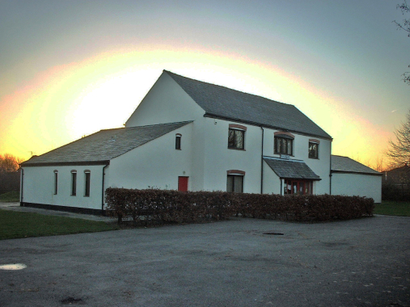

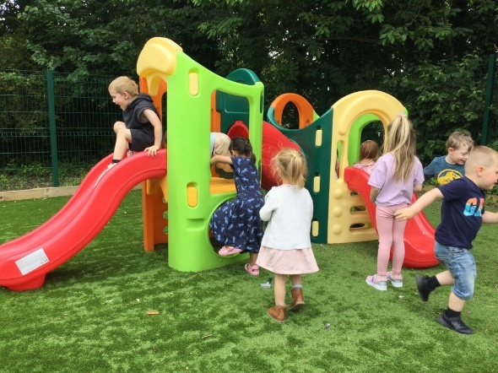
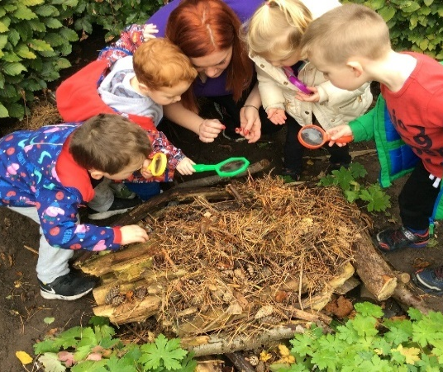

A little bit about us:
Jack and Jill Pre-school is a well-established local pre-school; we have members of the team that have been part of Jack and Jill for over 20 and 30 years and we have had the luxury of teaching children of the children that have attended here previously. We get lots of our enquires through word of mouth from past parents who have recommend us to family and friends.
We are a registered charity and non-for profit which enables us to operate at a good staffing level. We endeavor to be accessible to all family’s by running as a cost-effective pre-school who prides ourself on providing top quality but affordable childcare and early education. We are a homely setting with plenty of space and a large outdoor area; we have outside agencies such as phonics specialists, sports coaches and other fun classes such as Popcats come into pre-school to enable the children to have unique experiences.

At Jack and Jill Pre-School we are here to provide children from 2 years to school age a happy and healthy start in life by providing high-quality childcare that meets your child’s needs and interests. We hope that this guide gives you an introduction to how we will go about this using the Early Years Foundation Stage Framework and bespoke individual development plans devised by your child's key worker.

“Parents praise the staff and feel well informed about their children’s learning and development” - Ofsted June 2023
“Relationships are strong and children are happy. They thoroughly enjoy their time at this welcoming pre-school. Their smiling faces and motivation to have a go show that they feel fully at ease and part of the ‘Jack and Jill family” – Ofsted June 2023

Keyworkers and Groups

Jack and Jill’s keyworker system gives each member of staff responsibility for just a few children. Each child in the pre-school has one special adult to relate to, which can make settling in very much easier. In addition, the key worker can tailor the curriculum to the unique needs of each individual child in his or her group. The key worker maintains links with the child’s home setting, working with parents to ensure that all children are supported in reaching their full potential. We operate on a ‘buddy keyworker’ system meaning that each child also has a buddy keyworker incase their usual keyworker is off. Each buddy keyworker has a good knowledge of the child also knowing next steps and about their progress and development, this also gives parents a second point of contact.
You will be informed who is to be your child’s keyworker and buddy keyworker once we know the sessions your child is attending.
As part of each session, we split the children by age and development for a small part of the session. This allows us to provide more age-appropriate small group activities for the children and focused time with their keyworker. We also use this time to carry out ongoing observational checks to monitor their progress and work with your child to help them achieve their next goal. The names for the rooms when we split are ‘Caterpillar Room’ for the 2–3-year-old children and ‘Butterfly Room’ for children aged 3+ although this will also depend on your child’s ability not just their age, if we feel that they would benefit from more time in the caterpillar room this would be discussed with parents.

The Early Years Foundation Stage
The Early Years Foundation Stage (EYFS) is a legal framework which provides a set of requirements that we adhere to, to ensure that all children who attend our provision are safe and healthy, and that they are supported to learn and develop to their full potential. The EYFS requirements covers the following:
- The learning and development requirements shape the activities and experience we provide for your child.
- The early learning goals provide a general level of progress, covering knowledge, skills and understanding that we will support your child to work towards having by the end of the academic year in which they turn five.
- The assessment requirements detail how we will monitor and plan for your child’s progress.
- The safeguarding and welfare requirements are steps we follow to ensure your child is kept safe and has their welfare promoted.

Our policies and procedures explain in detail the steps we take to satisfy the requirements of the EYFS in our everyday practice. Please ask any member of our team to view our policies and procedures or alternatively they are available on our website. We are inspected and regulated by Ofsted on the quality of our childcare provision against the requirements of the EYFS. Please ask a member of our team to view a copy of the EYFS or our most recent “Good” Ofsted report.
Alternatively, you can view our most recent OFSTED report here:
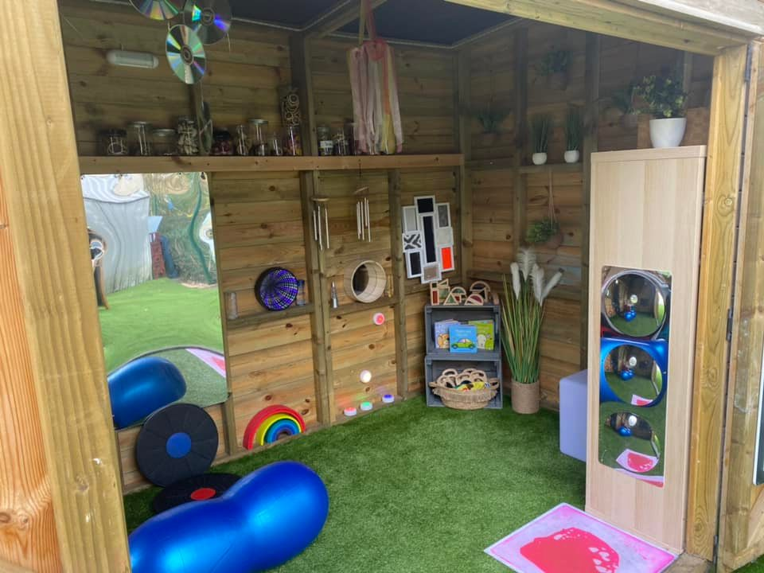
Ofsted | Jack & Jill Pre-School

Our curriculum:
-We use a mixture of information from the EYFS and development matters to create our room aims each year dependant on the cohort, this is a guide for all children when starting with us, moving up rooms, through to leaving us ready for school.
-We also create an individual termly plan for all children, using information from individual termly tracking of all areas of development plus our knowledge of the children helping to close any gaps in development. We plan and review these each term amending them accordingly. An example might be using the wellcomm big book of ideas if not on track with wellcomm assessments.
-We focus on the EYFS prime areas, in particular CLL and PSE development as we have recognised that these areas tend to need the most input for the children that attend our settings according to termly development tracking.

Our Planning- We use our annual topic planner as a background theme helping us to plan adult-led activities, alongside in the moment planning that follows the children’s interests, the termly plans also help us to plan activities for individual children’s development.
Our Aims: We have room aims/goals, we focus on the Prime areas of the EYFS, in particular CLL and PSE, which we believe hold the key skills to give each child the opportunity to build on all area of development enabling them to succeed to their potential.
Our Ethos: Our core values and beliefs- we use a mixture of approaches, we prioritise Communication and language development alongside Social and emotional development fostering positive relationships and emotional wellbeing, communication and language skills are crucial for overall development.
Our Values: What do we believe in- Our ethos is built on respect, kindness and inclusivity, regardless of background or ability, this ties in with British values and our golden rules, we promote equality of opportunity and we believe every child is unique with their own strengths and values.
Pedagogy: Teaching style - We support children’s development and learning through a child centred approach, building on the child’s natural curiosity of play-based learning, scaffolding on their experiences with support where we believe to be beneficial for their individual development and learning.
Our Vision/mission statement: To provide a space that is Safe, stimulating and nurturing, where Children can learn, grow, play, explore, engage and investigate in a place that feels like home, creating confidence and self-belief in all of our children.

How we support your child’s learning and development
Children start to learn about the world around them from the moment they are born. The care and education offered by our setting helps children to continue to do this by providing all of the children with interesting activities that are appropriate for their age and stage of development.

  - Prime Areas of Learning and Development
- Personal, social and emotional development
- Physical development
- Communication and language

  - Specific Areas of Learning and Development
- Literacy
- Mathematics
- Understanding the world
- Expressive arts and design

For each area, the level of progress that children are expected to have attained by the end of the Early Years Foundation Stage is defined by the Early Learning Goals. These goals state what it is expected that children will know, and be able to do, by the end of the reception year of their education.

How we assess your child’s progress
We observe your child throughout their time with us to identify their interests, how they learn and their progress in each area of learning and development. As parents we understand that you know your child best, so we take into account your “all about me “information when your child starts their place with us and we welcome any observations of your child from home; what they like to do, as well as any significant events, achievements but also if you have any concerns. We do our own baseline assessment of all areas of learning when your child starts with us and we use a speech and language screen (wellcomm) to help identify areas of development for your child’s keyworker to focus on; we then tailor a termly development plan for each child based on their individual needs. This continuous assessment of your child helps us to identify and plan their next steps in their development. We currently use an app that we use daily to upload pictures and videos of activities and what your child has been doing as well as memos and messages for parents, parents are able to log into this app and keep themselves updated and also update us of home life as this connection and partnership is very important.

  - Progress check at age two
If your child is aged between two and three years, your key worker will work with you to prepare a summary of their development in the prime areas of learning. The review may show that your child is progressing at a faster or slower rate in a particular area; this will generally be a normal part of your child’s unique development. If your two-year-old has not yet had their two-year health check with their health visitor, these can be combined into an integrated check at the pre-school with their key worker.

  - A school transition document
This summary of your child’s development over the seven main areas of learning is shared with yourselves and your child’s new reception teacher in preparation for them to move up to Reception.

The Management of the Pre-School
Jack and Jill Pre-School is a Charitable Incorporated Organisation run by elected trustees of which our management team are a part of, this ensures that major decision making is in the hands of those who have the pre-schools best interests at heart. Parents are welcome to join our committee of trustees, please let a member of the team know if this is something you are interested in. The general day-to-day running is by our Pre-School Management team.

The trustees can have an input in:
- The settings finances;
- The employment and managing the staff;
- The settings policies that help it provide a high quality and safe service;
- How the setting works in partnership with the children’s parents.

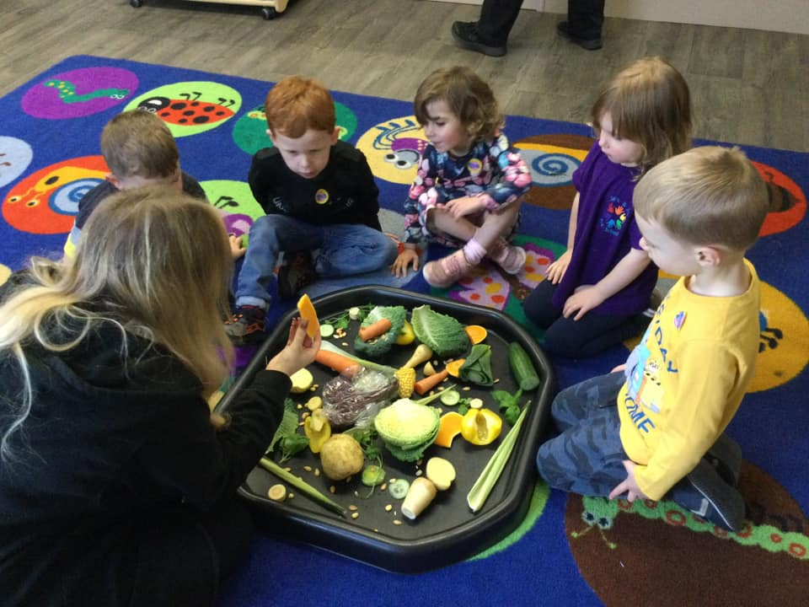
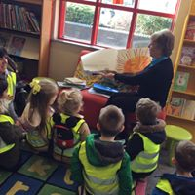
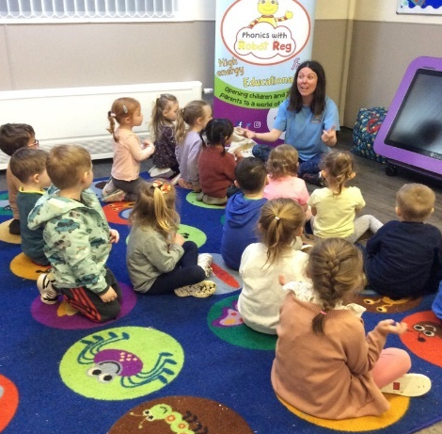

The Session

We organise our sessions so that the children can choose from, and work at, a range of activities and, in doing so, build up their ability to select and work through a task to its completion. The children are also helped and encouraged to take part in adult-led small and large group activities, which introduce them to new experiences and help them to gain new skills, as well as helping them to learn to work with others. Outdoor activities contribute to children's health, their physical development, and their knowledge of the world around them. The children have the opportunity, and are encouraged, to take part in outdoor child-chosen and adult-led activities, as well as those provided in the indoor classroom. We have regular visits out of the pre-school for nature walks, trips on the bus and to the library and we also currently have regular sports sessions taking place twice weekly. We have had various extra-curricular activities take place such as forest school, music sessions, phonics lessons, sports sessions, etc. these are charged at £2 per week, this fee is optional but helps us to provide a variety of extra-curricular activities for the children which are reviewed on a termly basis.

If you have more than one child attending Jack and Jill at the same time, we offer a 10% sibling discount off any privately paid fees for the second child.

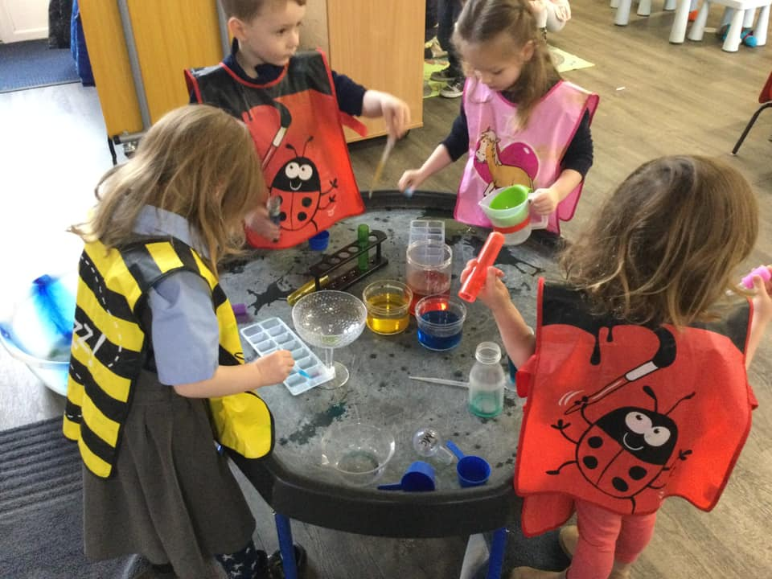
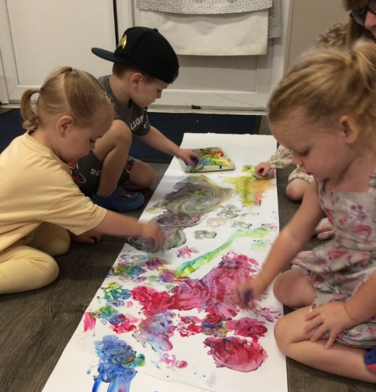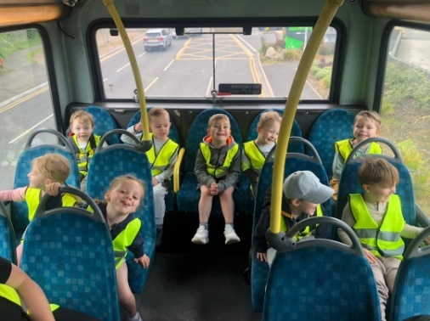

Opening Times
We are open term-time only, our opening times are listed below:
Monday | 9am – 12pm | 12pm – 3pm
Tuesday | 9am – 12pm | 12pm – 3pm
Wednesday | 9am – 12pm | 12pm – 3pm
Thursday | 9am – 12pm | 12pm – 3pm
Friday | 9am – 12pm | 12pm – 3pm
*NOTE Optional extra hours available from 8am and until 4pm at a small cost to yourselves.

We do request where possible that children attend a minimum of two sessions per week so that they can build relationships with their key-worker and familiarise them with the setting and routine.
Wraparound care -
*We have recently started to offer wrap around care sessions in the form of breakfast and after school club. Breakfast club sessions are either 8.00-9.00 or 8.30-9.00 and after school sessions are either 3.00-3.30 or 3.00-4.00. Sessions cost £3.50 for 30 minutes or £6.00 for 60 minutes. At breakfast club we provide your child with a selection of breakfast items and fruit and at after school club we provide your child with a substantial snack such as cheese and crackers, brioche, etc. as well as a selection of fruit. Milk and water are available during both sessions.
Wraparound care sessions are bookable weekly by email and are invoiced separately from your usual invoices, we do not use funding for these sessions but we can accept Tax-free childcare vouchers.

Snacks and Meals
We follow the Early years alliance guidelines for snack and we make snacks and meals a social time at which children and adults eat together. We plan our snack menu so that they provide the children with healthy and nutritious food eg fresh fruit and vegetables every day. Please tell us about your child's dietary needs or any allergies in your settling process and we can amend our menu to cater for these needs. We charge £2 per week for snack, this fee is optional but as a charity it helps us to provide fresh fruit every day and a variety of foods to try for special occasions too. We do not offer cooked meals at lunch time as we do not have cooking facilities, children attending afternoon sessions (after 12pm) will need to bring a packed lunch. We suggest a savory item such as sandwich or wrap, a dairy item (yoghurt or cheese), a piece of fruit and a small optional treat (plain biscuit/crisps) We provide water, cow’s milk and oat milk at snacks times and ask for children to bring a labelled bottle of water for throughout the day.
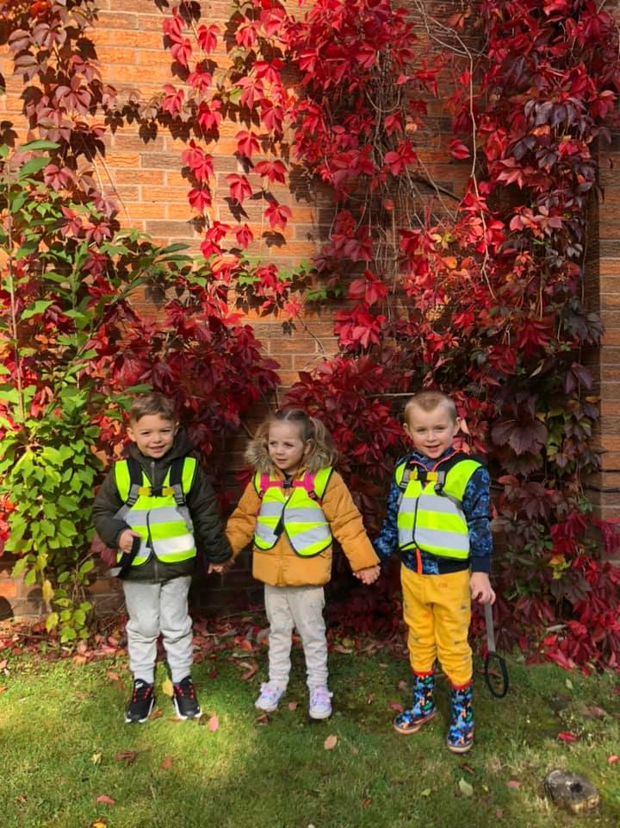
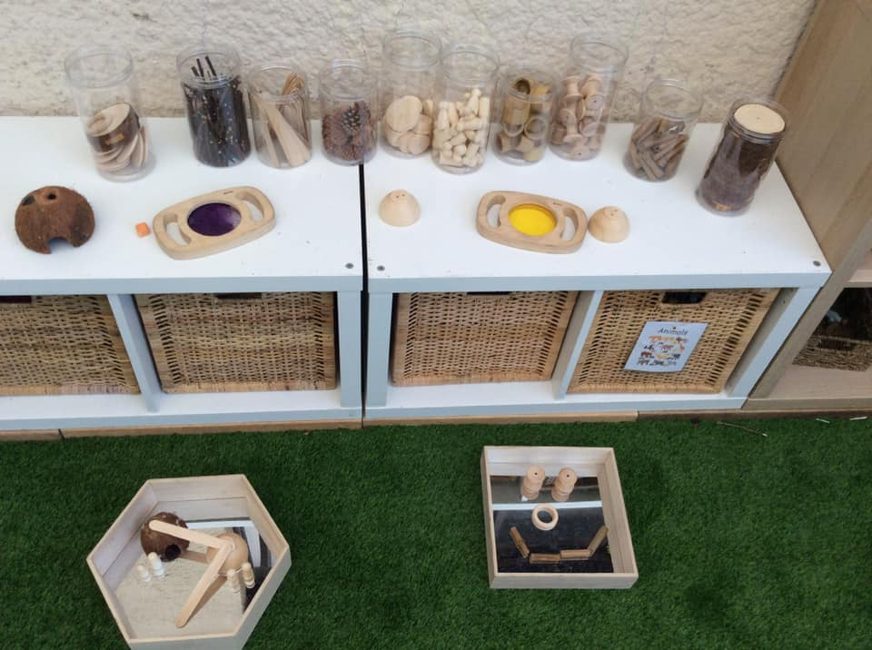
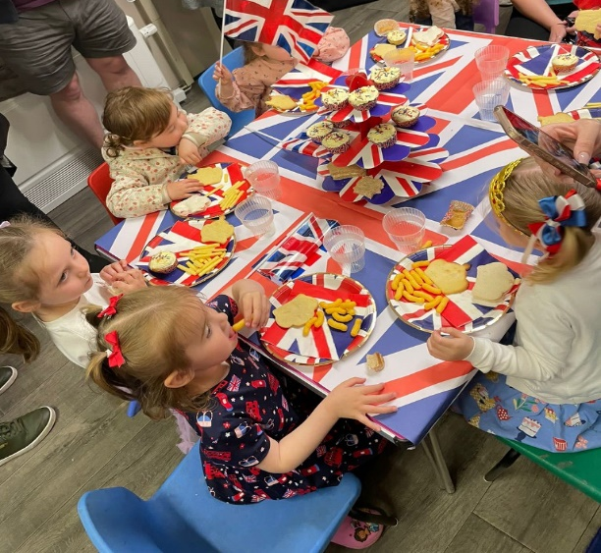

Fees
Our fees currently are £20.00 per session or £40.00 per full day. We review our fees yearly. Parents are made aware of any increases with plenty of notice, fees are reviewed annually. Invoices will be emailed in the first 2 weeks of each half term to be payable within 30 days for the coming half term. Fees must still be paid if children are absent for a brief period of time including sickness and holidays. In cases of prolonged absence, parents should consult the management or committee about fee payment. Each child’s attendance at the group is conditional upon continued payment of any necessary fees and/or eligibility for Early Education Funding. We accept ALL kinds of funding which includes the 30-hour funding for working parents, the universal 15 hours and the 15 hours 2-year-old funding scheme, we also accept childcare vouchers and tax-free childcare. Please check if you are eligible for funding before you want your place by filling out your details at Childcare & Early Years Education - Best Start in Life , if you are eligible for funding, you will likely be provided with a code when you apply and we will need this prior to your child start date to enable us to claim the funding on your behalf.

Meet the Team

Management Team;
Kaylea – Kaylea has been at Jack and Jill pre-school since January 2018, she has worked her way up from Early years educator to senior practitioner, then deputy manager and now pre-school manager since November 2022. Kaylea has worked in early years for many years so has lots of prior experience too. Kaylea is level 3 trained and a designated safeguarding lead. Kaylea’s favorite thing to do at jack and jill is outdoor play especially in the summer.
Emily H- Emily has been at Jack and Jill since October 2017; Emily has also worked her way up to deputy manager and now Manager since October 2023, Emily has also worked at other early years settings prior to Jack and Jill. Emily is level 3 trained and is a designated safeguarding lead. Emilys favorite thing to do at jack and jill is Dancing.

SENCO:
Holly- Holly is our special educational need coordinator, Holly can support children and their families with any SEND concerns and she can make referrals with the correct evidence needed. Holly has worked at Jack and jill since June 2018 She began here as a student prior to this and worked her way up to SENCO, she is also level 3 trained and is a designated safeguarding lead. Holly enjoys going on educational outings.

Early years educators:
Hayley- Hayley has been working at jack and jill since the day it opened in 1988, as you can imagine Hayley has had a lot of experience in that time, she is level 3 trained and holds a SENDCO qualification, Hayleys favorite thing to do at jack and jill is sports especially football.
Emma- Emma has been working at Jack and Jill since 2002, Emma is level 2 trained and enjoys working on her CPD often attending many training courses as they come up, Emma is also our health and safety officer as well as the sustainability lead. Emma enjoys forest school activities that we can do at our woodland area at the back of our field.
Amy- Amy has worked at jack and jill since February 2022 she has an early childhood degree and level 3 early years educator qualification, at jack and jill Amy mostly enjoys mark making activities.
Emily B- Emily has been working at Jack and Jill since February 2022, she has an early year’s educator level 3 qualification, at jack and jill Emily mostly enjoys planning exciting activities.
Jodie- Jodie has worked at jack and jill since November 2024, Jodie has also worked in other early years setting prior to coming to us so has plenty of experience of working with children aged 0-5 years, Jodie is level 2 trained and is our EAL coordinator, she attends regular training for speech and languages. Jodie’s favorite thing to do at Jack and Jill is messy play.

*All of our practioner’s have first aid training and basic safeguarding training.
Starting at Jack and Jill
You can arrange a visit to have a look around and meet the team, we will give you our relevant welcome forms to take home and fill in. If you decide to take a place at Jack and Jill you just need to return your completed registration form with a start date and sessions you require. Once you have returned your registration form, we will arrange 2 x free 1 hour settle in sessions for your child. We recommend you stay and play on the first session or you are welcome to sit out of view, we will give you some more forms to fill in that will let us know a little more about your child and introduce you to your child’s key worker member or staff. We recommend on the 2nd settle in session that you leave and give your child an opportunity to explore the surroundings without you, ready for when they start. Don’t worry each child is different and will settle at different paces, we will work alongside you to get them settled as smoothly as possible and you can make as many calls/texts as you like to check up on them during this time, if you feel that your child requires a more staged settling in, we can gradually build up to full-time hours.

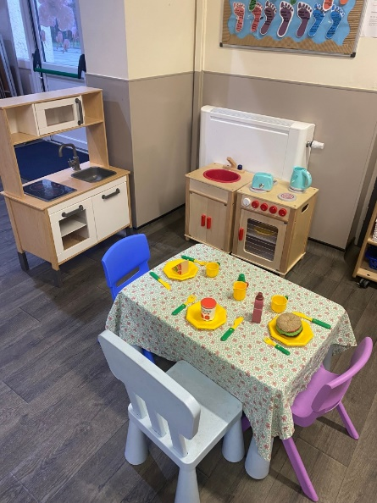
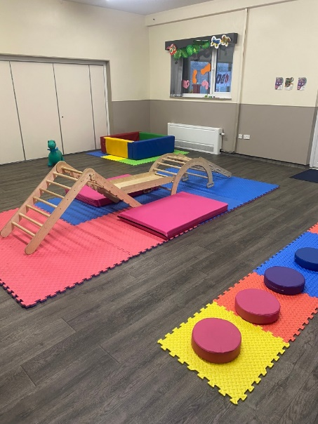
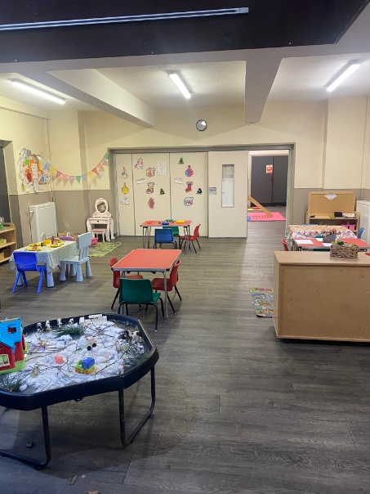
Waiting lists – we do open these up to 18 months in advance. If you join our waiting list you will be more likely to get the sessions you require for your needs, as many sessions do fill up really quickly. All we need is your child’s name, DOB and contact details as well as the days you require if you know these.

Term Dates for September 2026 to July 2027

Term | Opening Date | Closing Date
Autumn Term 1 | Wednesday 2nd September 2026 | Friday 23rd October 2026
Autumn Term 2 | Monday 9th November 2026 | *Friday 18th December 2026
Spring Term 1 | Monday 4th January 2027 | Friday 12th February 2027
Spring Term 2 | Monday 22nd February 2027 | Thursday 25th March 2027
Summer Term 1 | Wednesday 7th April 2027 | Friday 28th May 2027
Summer Term 2 | Monday 14th June 2027 | **Friday 23rd July 2027
Closed: May Bank Holiday (3rd May 2027)
*Half day only (am/pm) for Christmas party.
**Preschool leavers graduation only.

