


Jack and Jill Pre-School
Bewsey Barns Community Centre, Old Hall Road, Old Hall, Warrington, WA5 9PA Email: jackandjillwarrington@outlook.com Tel: 07513734288
Website: www.jackandjillwarrington.com

Registered Charity number: 1210915

Ofsted registration number: 2861969

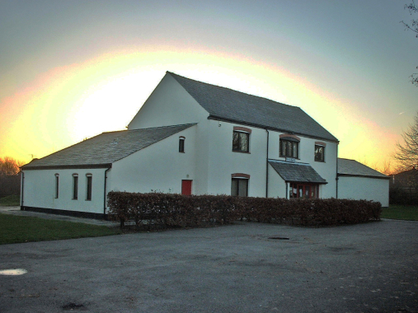

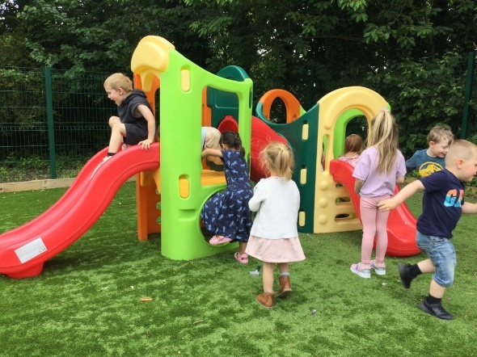
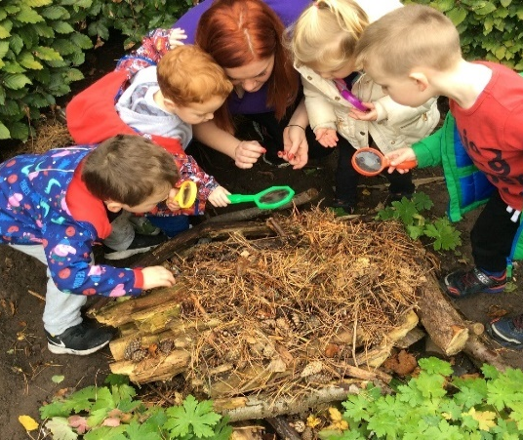

At Jack and Jill Pre-School we are here to give children (2 years to school age), a happy and healthy start in life by providing high quality childcare that meets your child’s needs and interests. We hope that this guide gives you an introduction to how we will go about this using the Early Years Foundation Stage Framework.

“Parents praise the staff and feel well informed about their children’s learning and development” - Ofsted June 2023
“Relationships are strong and children are happy. They thoroughly enjoy their time at this welcoming pre-school. Their smiling faces and motivation to have a go show that they feel fully at ease and part of the ‘Jack and Jill family” – Ofsted June 2023

Keyworkers and Groups

Jack and Jill’s keyworker system gives each member of staff responsibility for just a few children. Each child in the Pre-School has one special adult to relate to, which can make settling in very much easier. In addition, the key worker can tailor the curriculum to the unique needs of each individual child in his or her group. The key worker maintains links with the child’s home setting, working with parents to ensure that all children are supported in reaching their full potential. We operate on a ‘buddy keyworker’ system meaning that each child also has a buddy keyworker incase their usual keyworker is off. Each buddy keyworker has a good knowledge of the child also knowing next steps and about their progress and development, this also gives parents a second point of contact.
You will be informed who is to be your child’s keyworker and buddy keyworker once we know the sessions your child is attending.
As part of each session, we split the children by age and development for a small part of the session. This allows us to provide more age-appropriate small group activities for the children and focused time with their keyworker. We also use this time to carry out ongoing observational checks to monitor their progress and work with your child to help them achieve their next goal. The names for the rooms when we split are ‘Caterpillar Room’ for the 2-3 year old’s and ‘Butterfly Room’ for children aged 3+.

The Early Years Foundation Stage
The Early Years Foundation Stage (EYFS) is a legal framework which provides a set of requirements that we adhere to, to ensure that all children who attend our provision are safe and healthy, and that they are supported to learn and develop to their full potential. The EYFS requirements covers the following:
- The learning and development requirements shape the activities and experience we provide for your child.
- The early learning goals provide a general level of progress, covering knowledge, skills and understanding that we will support your child to work towards having by the end of the academic year in which they turn five.
- The assessment requirements detail how we will monitor and plan for your child’s progress.
- The safeguarding and welfare requirements are steps we follow to ensure your child is kept safe and has their welfare promoted.

Our policies and procedures explain in detail the steps we take to satisfy the requirements of the EYFS in our everyday practice. Please ask any member of our team to view our policies and procedures or alternatively they are available on our website. We are inspected and regulated by Ofsted on the quality of our childcare provision against the requirements of the EYFS. Please ask a member of our team to view a copy of the EYFS or our most recent “Good” Ofsted report.
Alternatively you can view our most recent OFSTED report here:
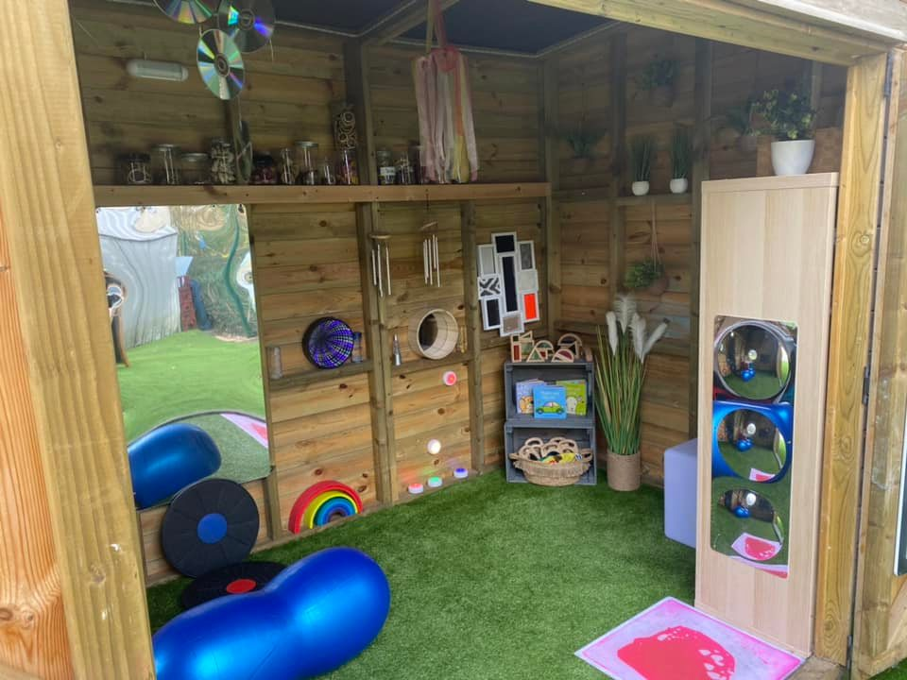
Ofsted | Jack & Jill Pre-School

How we support your child’s learning and development
Children start to learn about the world around them from the moment they are born. The care and education offered by our setting helps children to continue to do this by providing all of the children with interesting activities that are appropriate for their age and stage of development.

  - Prime Areas of Learning and Development
- Personal, social and emotional development
- Physical development
- Communication and language

  - Specific Areas of Learning and Development
- Literacy
- Mathematics
- Understanding the world
- Expressive arts and design

For each area, the level of progress that children are expected to have attained by the end of the Early Years Foundation Stage is defined by the Early Learning Goals. These goals state what it is expected that children will know, and be able to do, by the end of the reception year of their education.

How we assess your child’s progress
We observe your child throughout the day to identify their interests, how they learn and their progress in each area of learning and development. As parents, you know your child best, so we also want to hear your observations of your child; what they like to do at home, as well as any significant events, achievements but also if you have any concerns. This continuous assessment of your child helps us to identify and plan their next steps. We currently use an app that we use daily to upload pictures and videos of activities and what your child has been doing as well as memos and messages for parents, parents are able to log into this app and keep themselves updated and also update us of home life as this connection and partnership is very important.

  - Progress check at age two
If your child is aged between two and three years, your key worker will work with you to prepare a summary of their development in the prime areas of learning. The review may show that your child is progressing at a faster or slower rate in a particular area; this will generally be a normal part of your child’s unique development. If your two-year-old has not yet had their two-year health check with their health visitor, these can be combined into an integrated check at the Pre-School with their key worker.

  - A school transition document
This summary of your child’s development over the seven main areas of learning is shared with yourselves and your child’s new reception teacher in preparation for them to move up to Reception.

The Management of the Pre-School
Jack and Jill Pre-School is an Unincorporated Charitable Organisation run by an elected committee of parents, which ensures that major decision making is in the hands of those who use the group. Our Annual General Meeting, at which the committee for the following year is elected, is held in the Autumn Term and parents will be informed in good time so they are able to attend. Any committee vacancies are distributed firstly to the parents 28 days prior to the AGM. The day-to-day running is by our Pre-School Management team and is no different to other settings.

The Committee and Pre-School Management are responsible for:
- Managing the settings finances;
- Employing and managing the staff;
- Making sure that the setting has, and works to policies that help it provide a high quality and safe service;
- Making sure that the setting works in partnership with the children’s parents.

The Annual General Meeting is open to parents of all of the children who attend the setting. It is our shared forum for looking back over the previous year’s activities and shaping the coming year’s plan.

Parent Volunteers
Parents can offer to take part in a session by sharing their own interests and skills with the children. Parents have visited the setting to take part in cultural food taster days, planting in the garden and bring is special items from home that coincide with our termly topics. Parents and carers are encouraged to attend our Stay and Play Sessions as these are a great way to see the things the children get up to at Pre-School and for your child to show you their interests whilst they are here. Our stary and play sessions are also a great way to connect with all the staff and catch up with other parents too supporting your children build those important friendships.

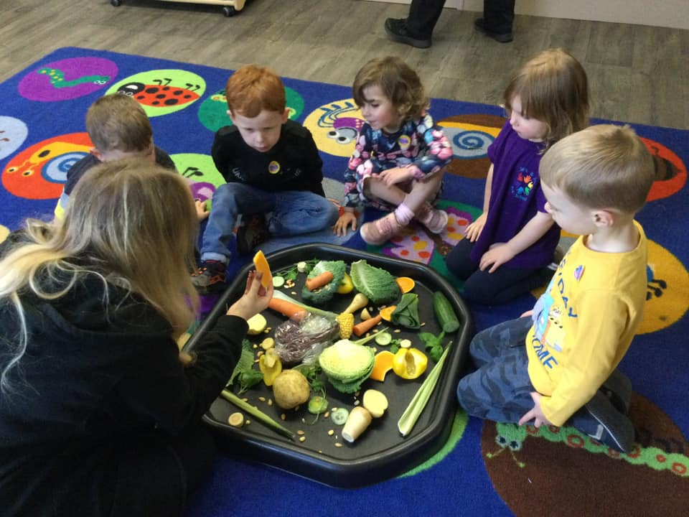
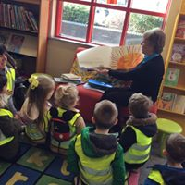
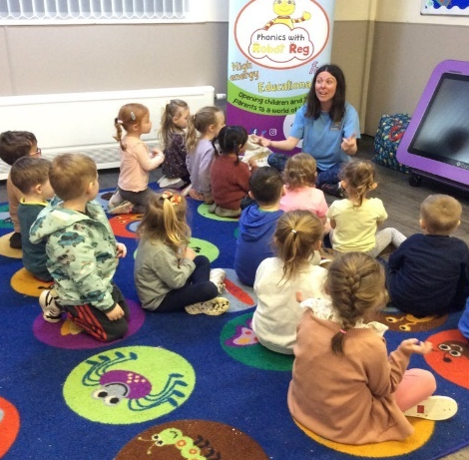

The Session

We organise our sessions so that the children can choose from, and work at, a range of activities and, in doing so, build up their ability to select and work through a task to its completion. The children are also helped and encouraged to take part in adult-led small and large group activities, which introduce them to new experiences and help them to gain new skills, as well as helping them to learn to work with others. Outdoor activities contribute to children's health, their physical development, and their knowledge of the world around them. The children have the opportunity, and are encouraged, to take part in outdoor child-chosen and adult-led activities, as well as those provided in the indoor classroom. We have regular visits out of the Pre-School for nature walks, trips on the bus and to the library and we also currently have regular sports sessions taking place twice weekly. We have had various extra-curricular activities take place such as forest school, music sessions, phonics lessons, sports sessions, etc these are charged at £2 per week, this fee is optional but helps us to provide a variety of extra-curricular activities for the children which are reviewed on a termly basis.

If you have more than one child attending Jack and Jill at the same time, we offer a 10% sibling discount off any privately paid fees for the second child.

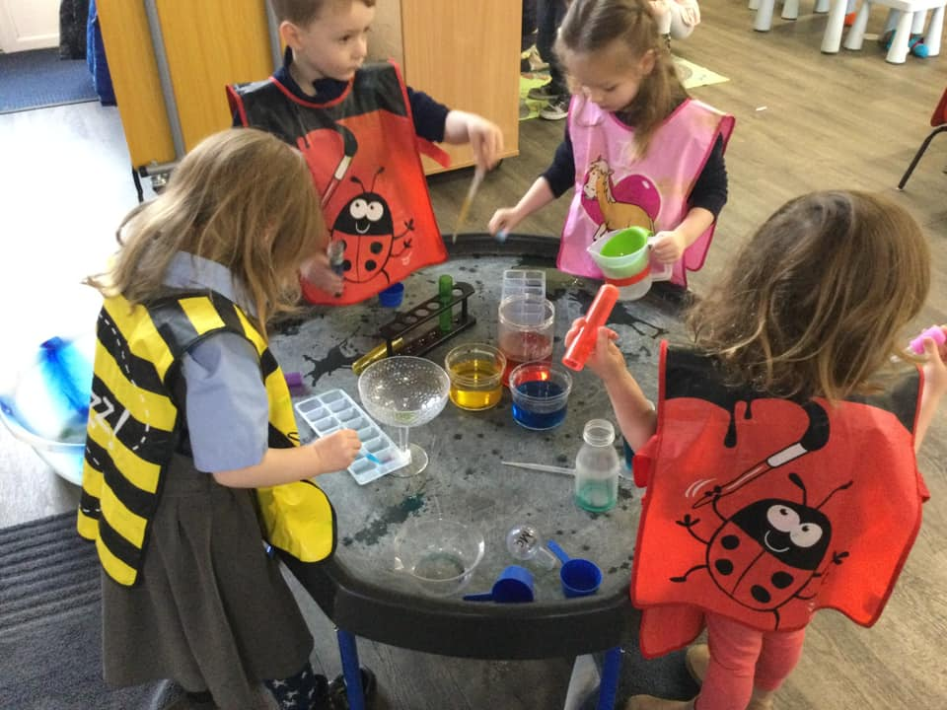
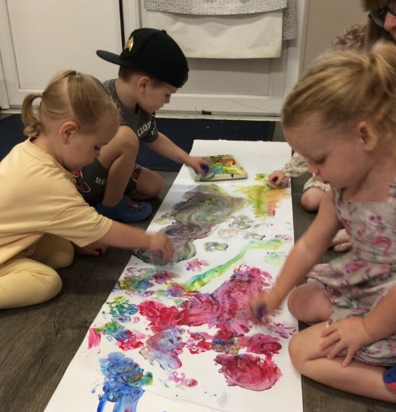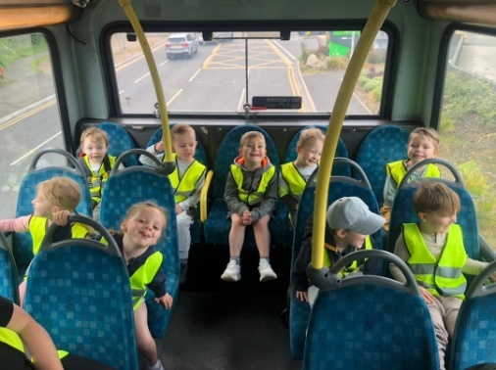

Opening Times
We are open term-time only, our opening times are listed below:
Monday | 9am – 12pm | 12pm – 3pm
Tuesday | 9am – 12pm | 12pm – 3pm
Wednesday | 9am – 12pm | 12pm – 3pm
Thursday | 9am – 12pm | 12pm – 3pm
Friday | 9am – 12pm | 12pm – 3pm
*NOTE Optional extra hours available from 8am and until 4pm at a cost to yourselves.

We do request where possible that children attend a minimum of two sessions per week so that they can build relationships with their key-worker and familiarise them with the setting and routine.
Wraparound care -
*We have recently started to offer wrap around care sessions in the form of breakfast and after school club. Breakfast club sessions are either 8.00-9.00 or 8.30-9.00 and after school sessions are either 3.00-3.30 or 3.00-4.00. Sessions cost £3.50 for 30 minutes or £6.00 for 60 minutes. At breakfast club we provide your child with a selection of breakfast items and fruit and at after school club we provide your child with a substantial snack such as cheese and crackers, brioche, etc as well as a selection of fruit. Milk and water is available during both sessions.
Wraparound care sessions are bookable weekly by email and are invoiced separately from your usual invoices, we do not use funding for these sessions but we can accept Tax-free childcare vouchers.

Snacks and Meals
We follow the Early years alliance guidelines for snack and we make snacks and meals a social time at which children and adults eat together. We plan our snack menu so that they provide the children with healthy and nutritious food. Please tell us about your child's dietary needs or any allergies in your settling process and we can plan our menu to cater for these needs. We charge £2 per week for snack, this fee is optional but as a charity it helps us to provide fresh fruit every day and a variety of foods to try for special occasions too. We do not offer cooked meals at lunch time as we do not have cooking facilities, children attending afternoon sessions will need to bring a packed lunch. We suggest a savory item such as sandwich or wrap, a dairy item (yoghurt or cheese), a piece of fruit and an optional treat (biscuit, crisps, cake) We provide water and milk at snacks times and ask for children to bring a labelled bottle of water for throughout the day.
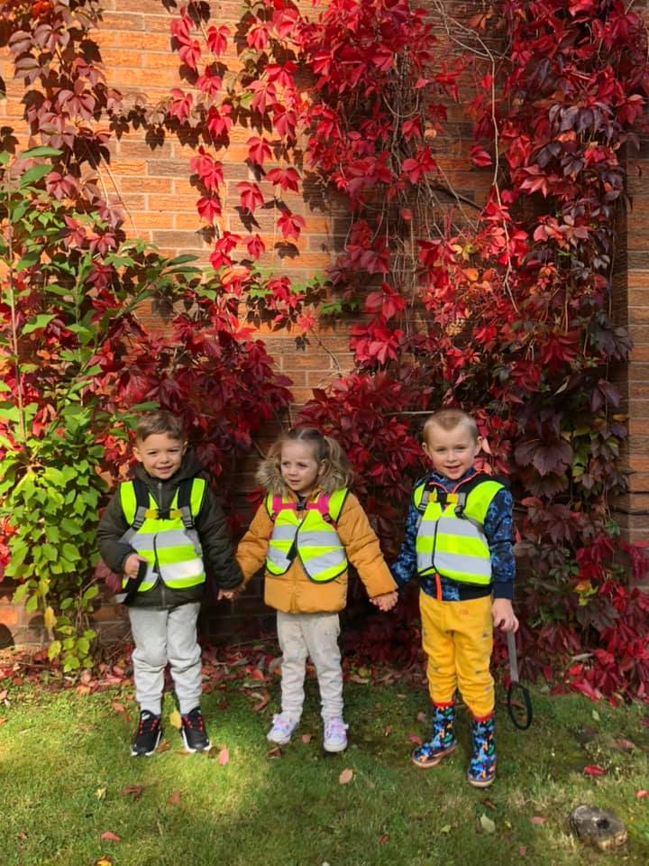
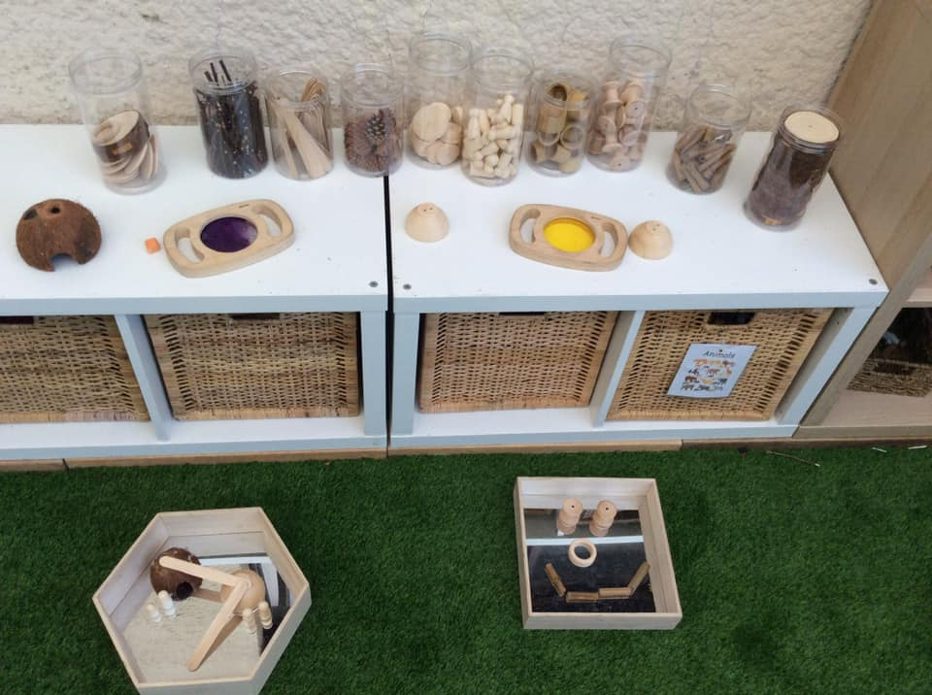
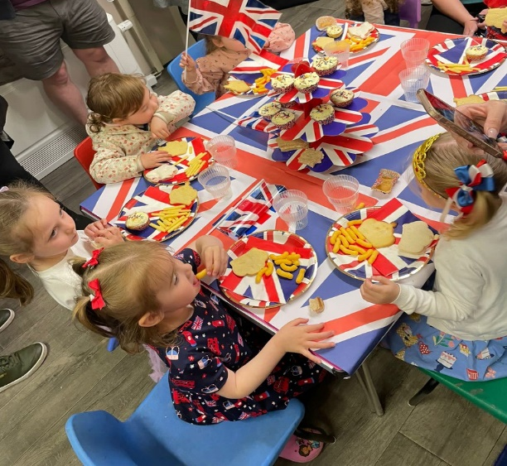

Fees
Our fees as of April 2025 are £20.00 per session or £40.00 per full day. We review our fees yearly.Parents are made aware of any increases with plenty of notice, fees are reviewed annually. Invoices will be emailed in the first 2 weeks of each half term to be payable within 30 days for the coming half term. Fees must still be paid if children are absent for a brief period of time including sickness and holidays. In cases of prolonged absence, parents should consult the management or committee about fee payment. Each child’s attendance at the group is conditional upon continued payment of any necessary fees and/or eligibility for Early Education Funding. We accept ALL kinds of funding which includes the 30-hour funding for working parents, the universal 15 hours and the 15 hours 2-year-old funding scheme, we also accept childcare vouchers and tax-free childcare. You may be eligible for help towards fees - please ask for details in confidence or if you need any help applying for funding www.childcarechoices.gov.uk can also provide you with lots of options for help towards childcare costs.
Starting at Jack and Jill
You can arrange a visit to have a look around and meet the team, we will give you our relevant welcome forms to take home and fill in. If you decide to take a place at Jack and Jill you just need to return your completed registration form with a start date and sessions you require. Once you have returned your registration form, we will arrange 2 x free 1 hour settle in sessions for your child. We recommend you stay and play on the first session or you are welcome to sit out of view, we will give you some more forms to fill in that will let us know a little more about your child and introduce you to your child’s key worker member or staff. We recommend on the 2nd settle in session that you leave and give your child an opportunity to explore the surroundings without you, ready for when they start. Don’t worry each child is different and will settle at different paces, we will work alongside you to get them settled as smoothly as possible and you can make as many calls/texts as you like to check up on them during this time.

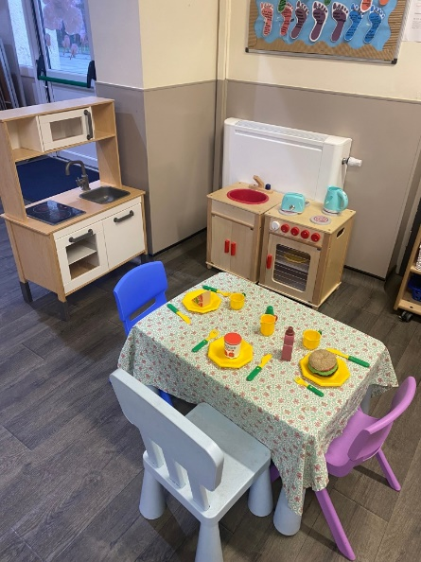
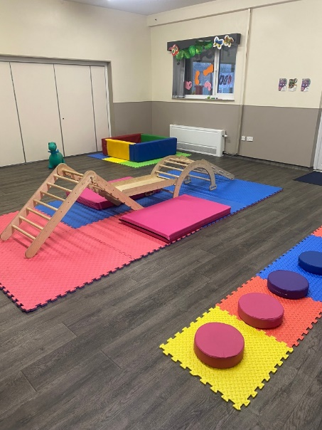
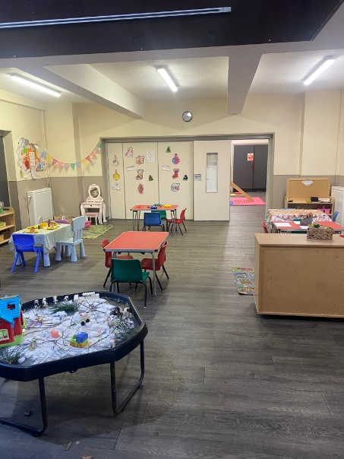
Waiting lists – we do open these up to a year in advance. If you join our waiting list you will be more likely to get the sessions you require for your needs, as many sessions do fill up really quickly. All we need is your child’s name, DOB and contact details as well as the days you require if you know these.

Term Dates for September 2025 to July 2026

Term | Opening Date | Closing Date
Autumn Term 1 | Tuesday 2nd September 2025 | Friday 17th October 2025
Autumn Term 2 | Monday 3rd November 2025 | Friday 19th December 2025
Spring Term 1 | Monday 5th January 2026 | Friday 13th February 2026
Spring Term 2 | Monday 23rd February 2026 | Thursday 2nd April 2026
Summer Term 1 | Tuesday 14th April 2026 | Friday 22nd May 2026
Summer Term 2 | Monday 8th June 2026 | Friday 24th July 2026
Closed: May Bank Holiday (5th May 2026)

